**2025 Junior Tai Kai**

**Saturday March 22**

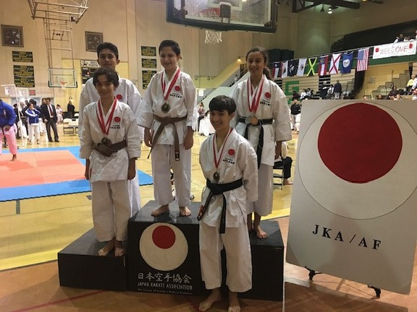

**Kata, Kumite and Team**

**Events**

**Dan Exams to Sandan**

**Delray Beach Community Center**

**50 NW 1st Avenue Delray Beach**

# Schedule

**Saturday March 22**

**Delray Beach Community Cente**r

**Tournament 9AM-1PM**

**1 PM Dan Exams**

# 

There will be Dan exams to SANDAN level. You must sign up in advance. If you don't pass, registration fees will be refunded.

You must in advance email a copy of your previous rank certificate ,kyu or dan ranking. In addition, all annual registration fees for JKAAF should be current.

If your instructor is not present we will require a permission letter from your instructor allowing you to test for Dan ranking.

Send all the information regarding dan exams to elbualy@gmail.com

## EVENT LOCATION

City of Delray Beach - Community Center

50 NW 1st Ave, Delray Beach, FL 33444

Tournament entry fee $20 per person all events total

**Tournament Events**

Age divisions from 6-18

Beginner/intermediate/advanced

KATA and Kumite individual events

Team Kata